Enzyme Information and Learning Activity
Enzymes are proteins that allow certain chemical reactions to take place much quicker than the reactions would occur on their own. Enzymes function as catalysts, which means that they speed up the rate at which metabolic processes and reactions occur in living organisms. The reactions would occur on their own without an enzyme, but they would happen so slowly that the cell would likely die before the reaction occurred. (Some enzymes cause reactions to happen at a rate of 40,000/sec!!)
Each step of an enzymatic reaction requires a specific enzyme. Without the specific enzyme to catalyze a reaction, the cycle or pathway cannot be completed.

Use the following diagrams to help understand how a specific enzyme is needed in order to catalyze a reaction.
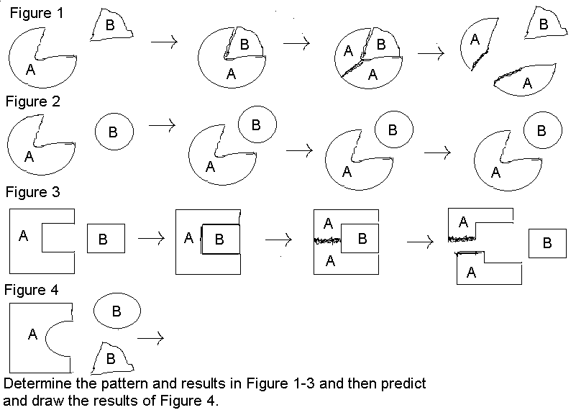
How do these diagrams illustrate that an enzyme specific to its substrate is needed for a reaction to occur?

In figure 4 above, if only triangle B was available, would the reaction occur? Why or why not?

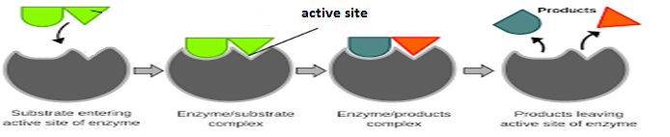
Use the diagram below to see how an enzyme-substrate reaction works.
The substrate is a molecule that an enzyme acts upon. The enzyme has an area called the active site, which is the part of the enzyme where the substrate binds. This fit must be perfect in order for the enzyme and substrate to bind. After binding, the substrate is broken down into the products.

Look at the diagram below. In this case, the reaction is to break down lactose (a disaccharide) into glucose and galactose (both monosaccharides). Some enzymes cause two molecules to bond together, forming a polymer from monomers.

Label the molecules above as substrate and enzyme and show where the active site is.
From the above reaction, can you determine how enzymes are named?

Notice that the enzyme name begins with the first part of the substrate name. In this case, lactose is the substrate so lact- is the beginning of the enzyme name. All enzymes end with –ase. Therefore, this enzyme is called lactase.
What would the enzyme name for the following molecules be?
Catalose

Protein

Lamose

Carotene

